## User Documentation/Guide/Manual

**User Entity**

From Homepage to User page:

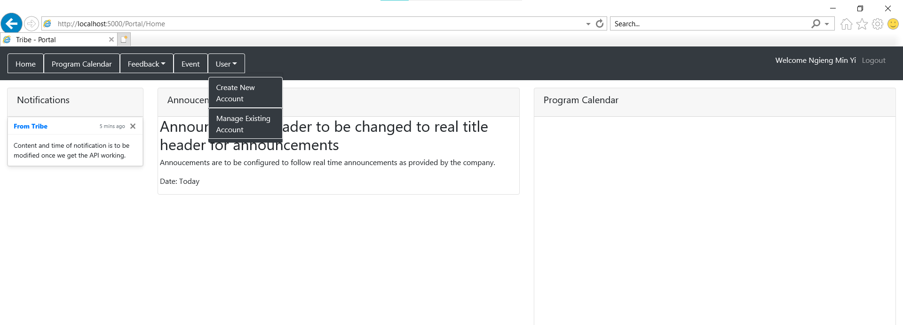

From the Homepage, we can see the word “User” at the navigation bars found at the top.

Click on the “User” and select either “Create New Account” or “Manage Existing Account”

**Creating a new user through User Entity:**

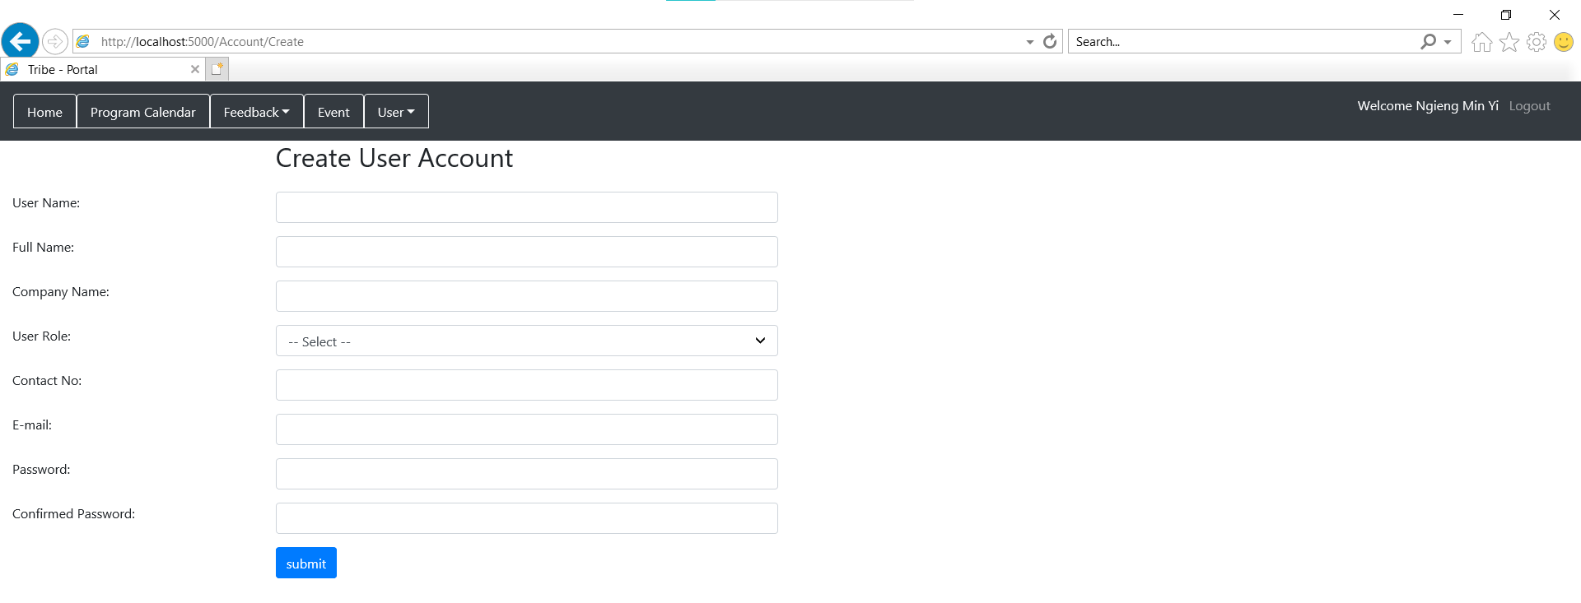

From the Homepage, client “User”, then click “Create New Account” in order to create a new user. Complete all the necessary fields. Fill in the User Name, Full Name, Company Name, User Role, Contact No., E-mail, password and confirmed password.

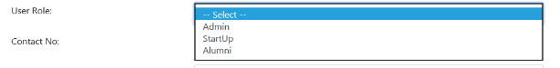

User role is to specify which user role we are creating for the new user. We can select 3 types of user roles, admin, startup and alumni.



E-mail is to send the activation email to the user once the user is created.

An example of a created user account:

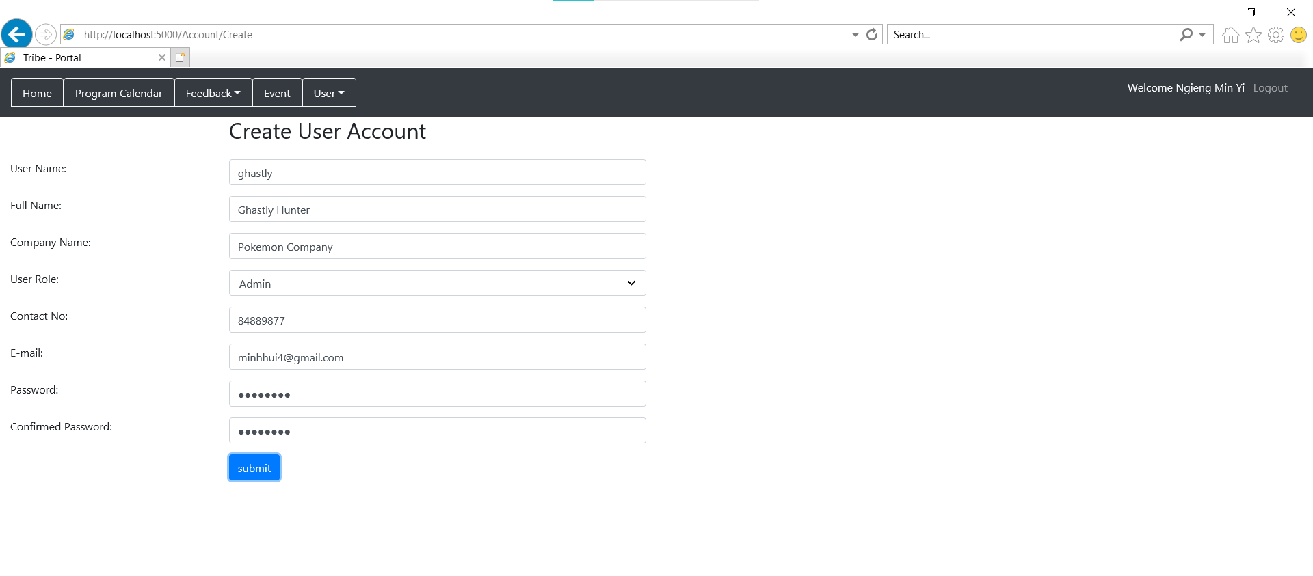

**Activation Email User Account:**

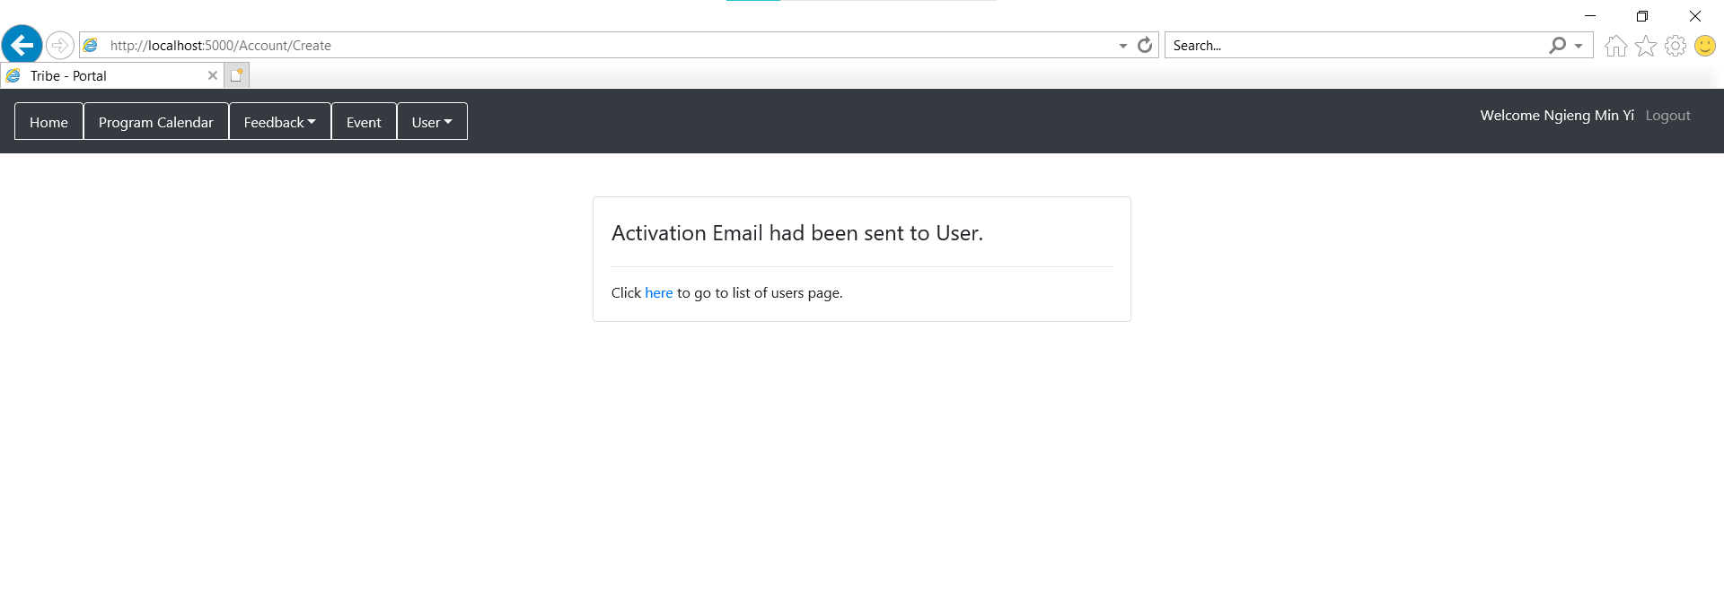

Click “here” to go to list of users page

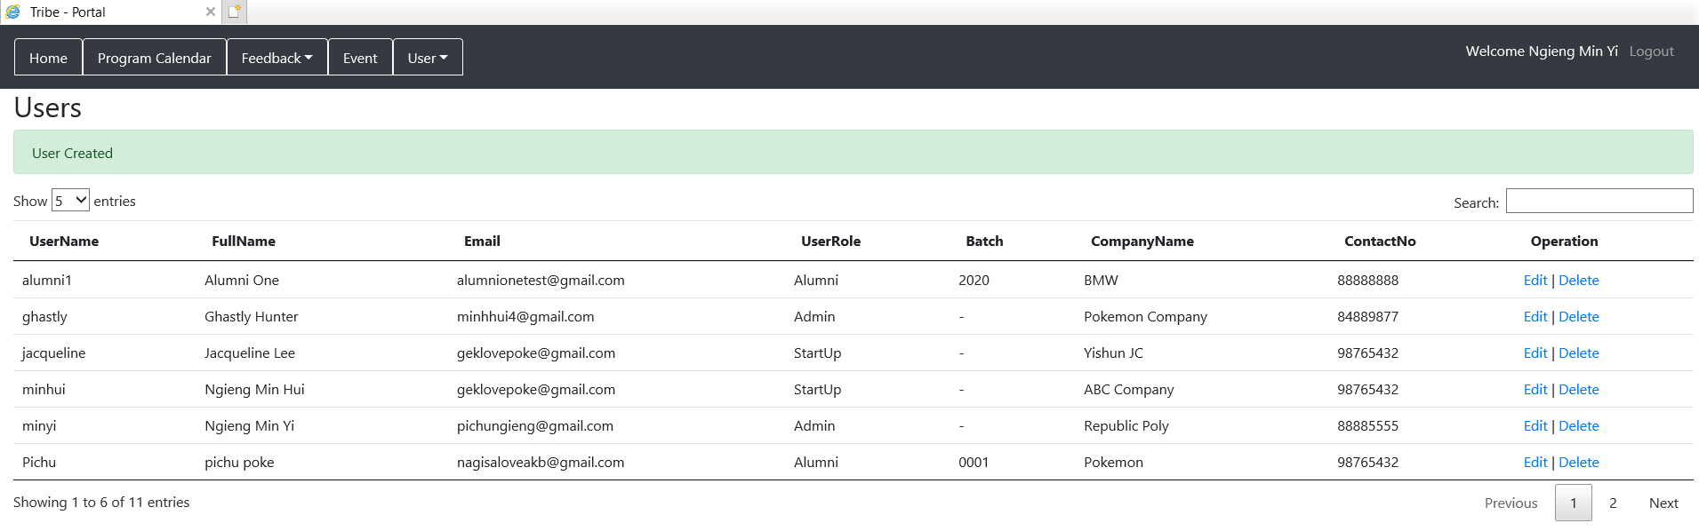

An email will be sent to the user: an example:

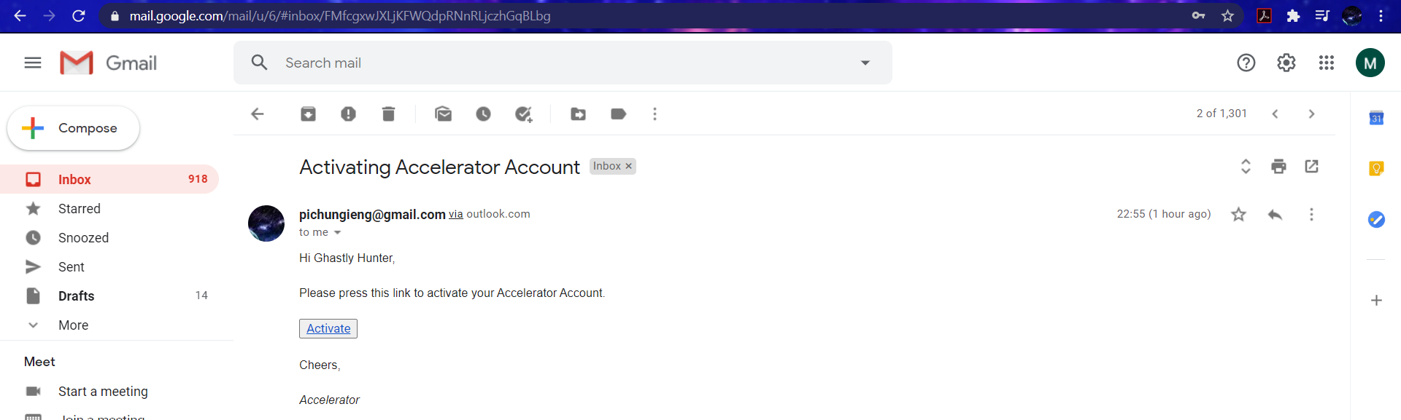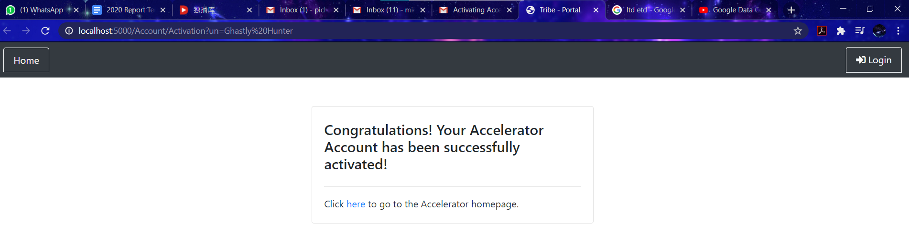

Click on the “Activate” to activate the user account.

**Edit user details**

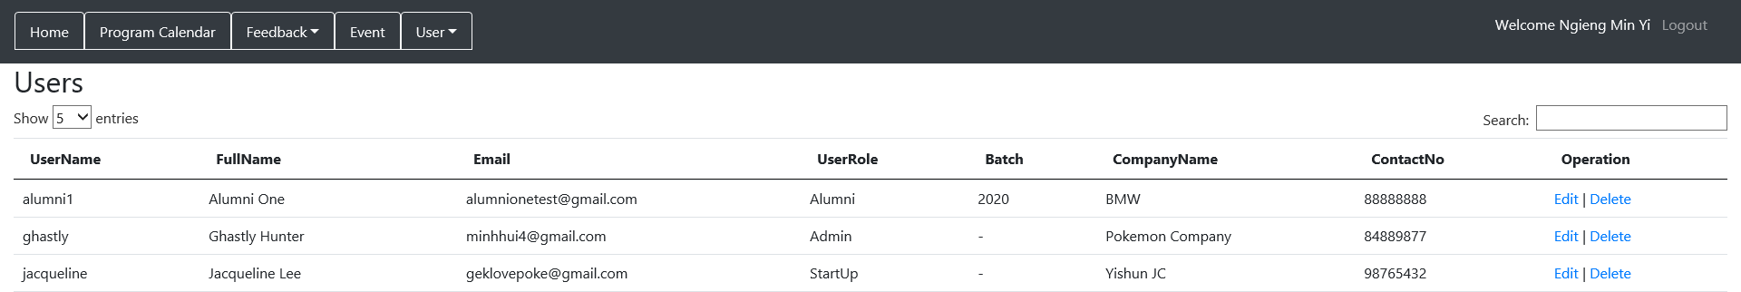

From the Homepage, click “User” then click “Manage Existing Account” to see the User list.

From there, click on “Edit” located at the “Operation” Column.

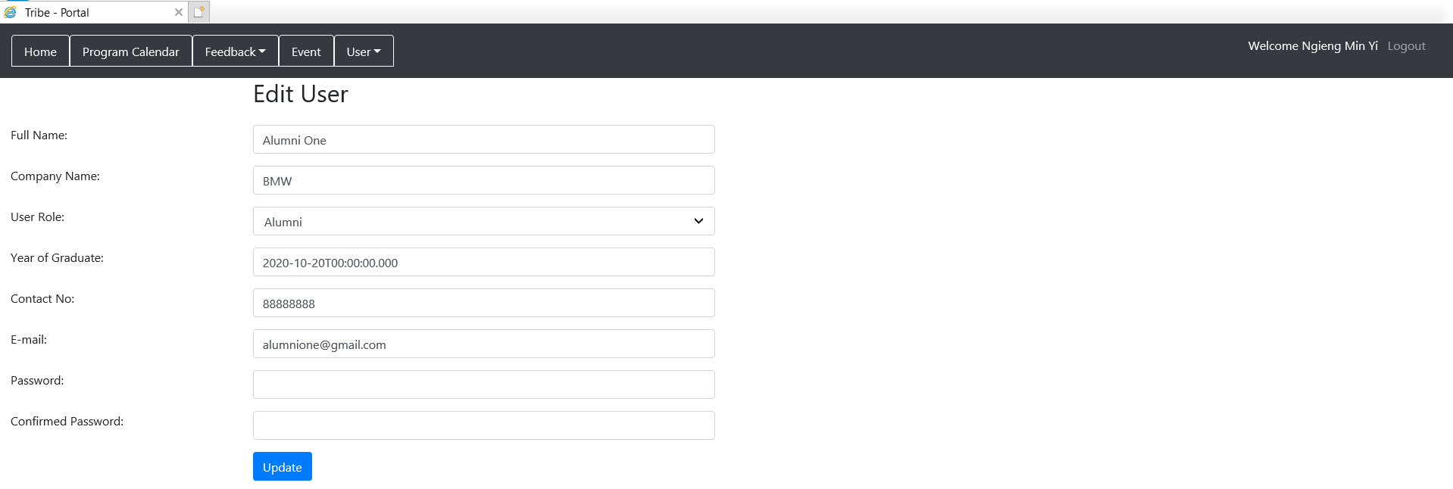

This will be the “Edit User” page of the first user. We can change anything from all the fields. Then, after we have changed any of the fields, we will then click “Update”.

For example, if we were to change the email of the user.



After clicking “Update”, it will then show the User list page and the new updated details will be shown.

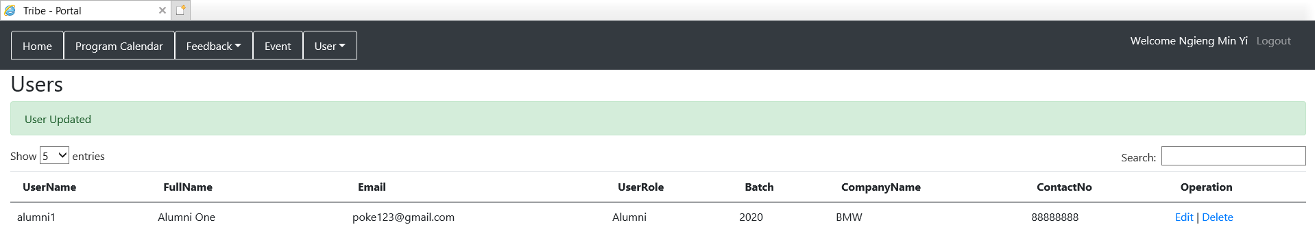

**Deleting a user**

From the User List page, we will click “Delete” and when there will be a prompt.

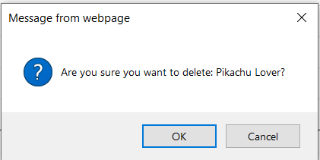

Click “OK”

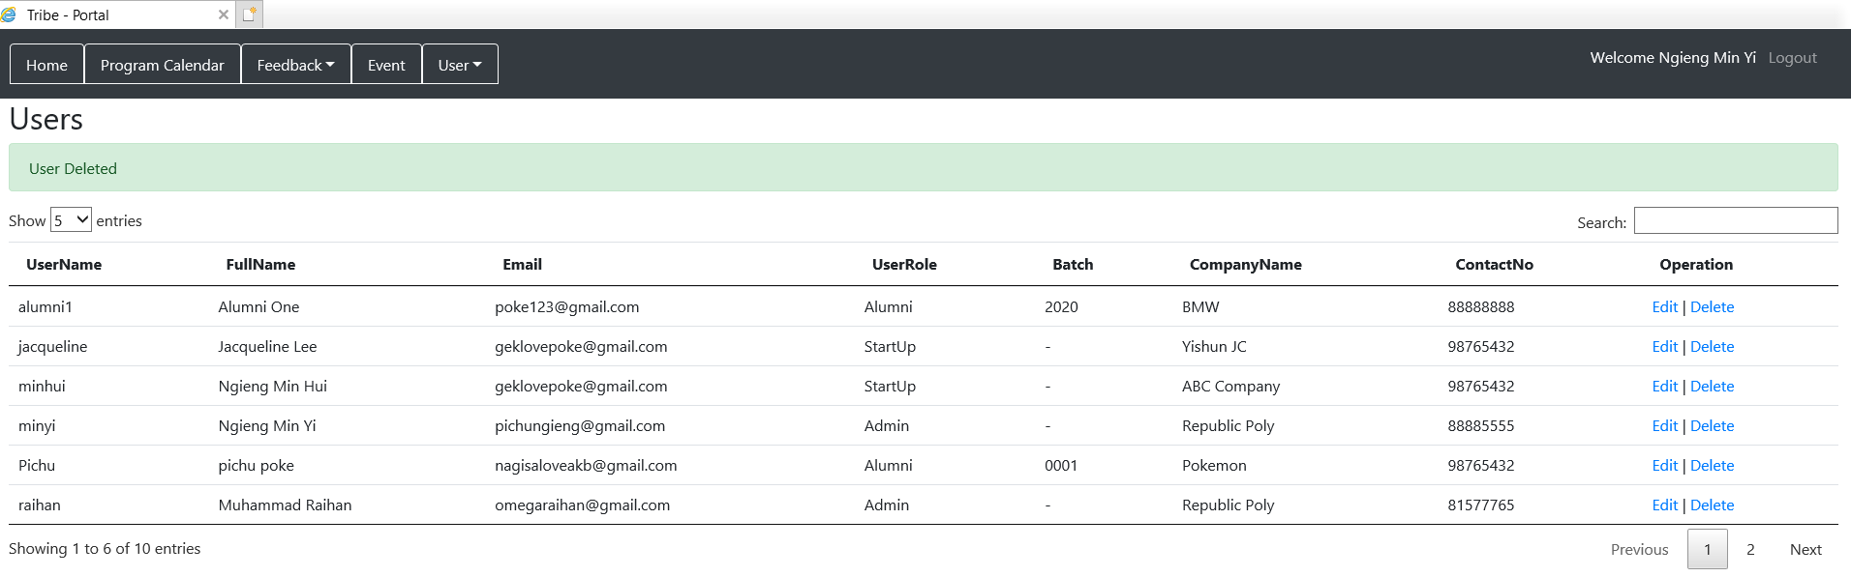

Then the deleted user will not be shown in the user list anymore.

**Reset Password [Startup/Alumni]**

From the Homepage, click “Account Management” on the navigation bars located on top.

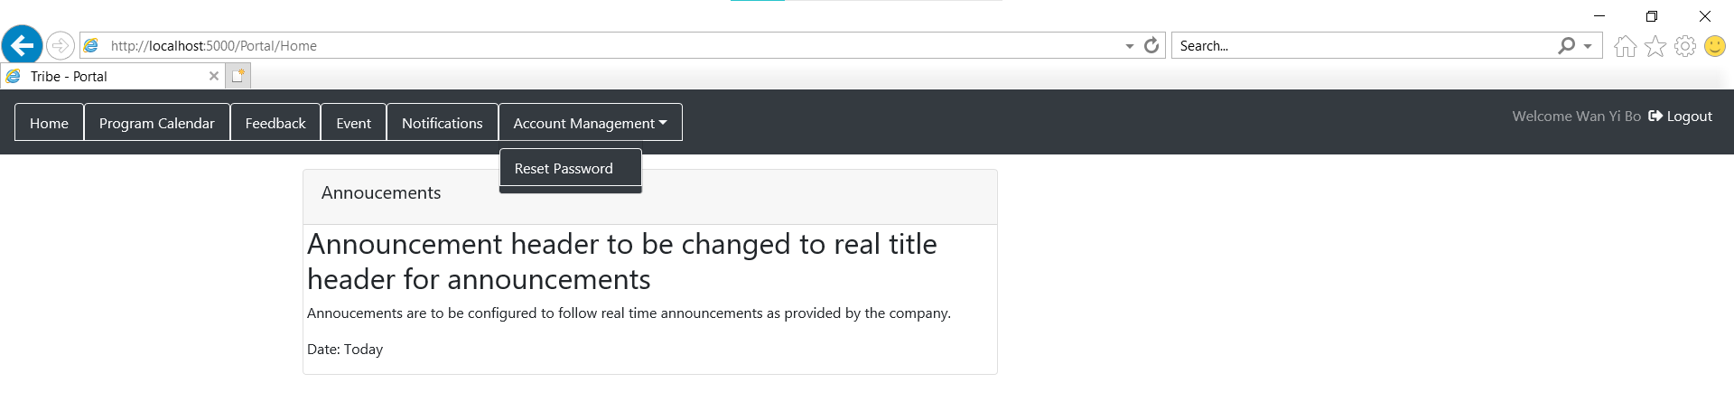

Click “Reset Password”

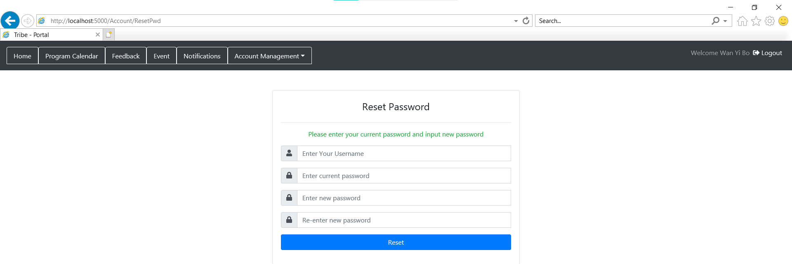

Complete all the necessary fields. Fill in the username, current password, new password and old password. Username and current password is for verification purposes.

For example

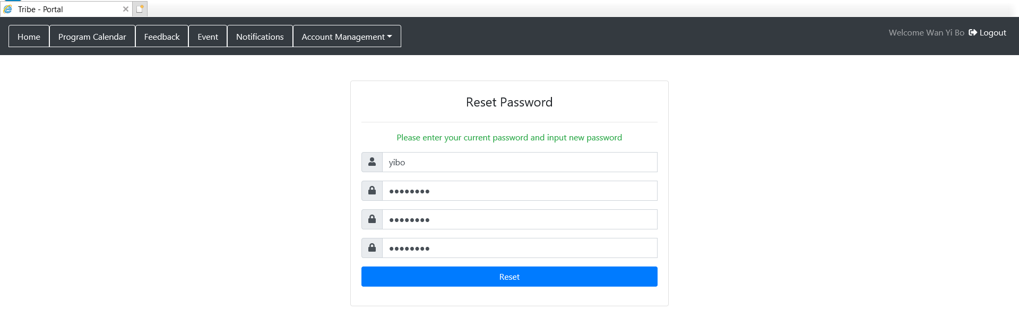

After clicking “Reset”, it will show that the password has been reset successfully.

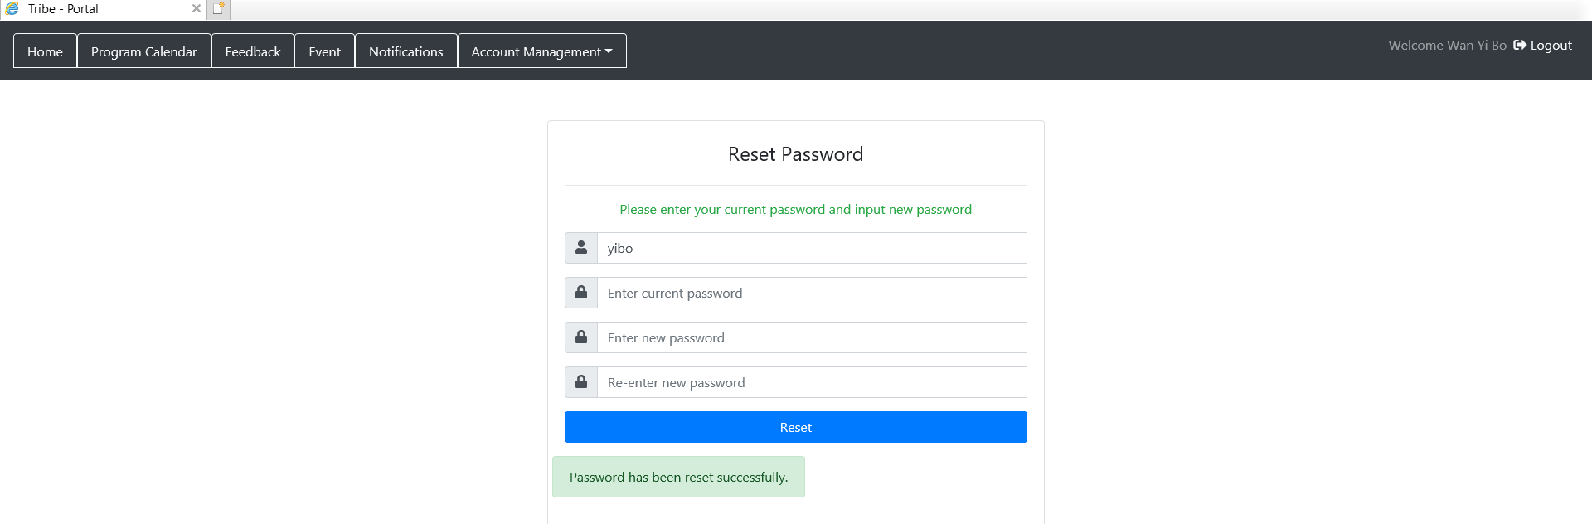

**Forgot Password [Admin/Startup/Alumni]**

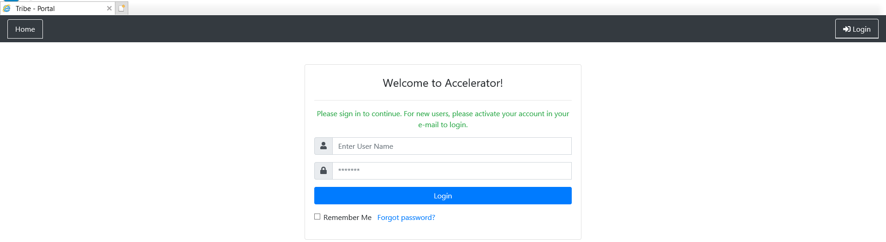

Click “Forgot password?”

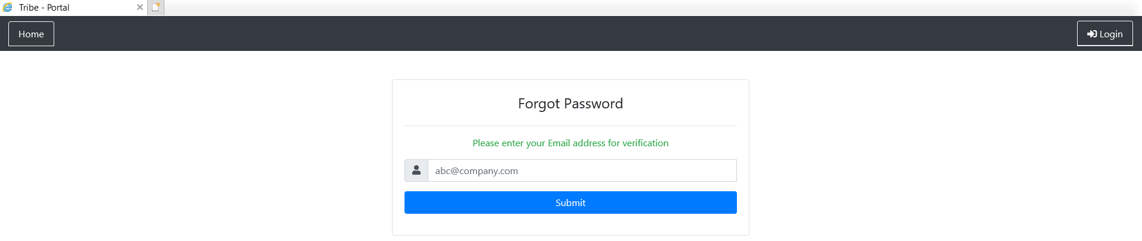

Fill in the necessary fills with the user’s email. An example:

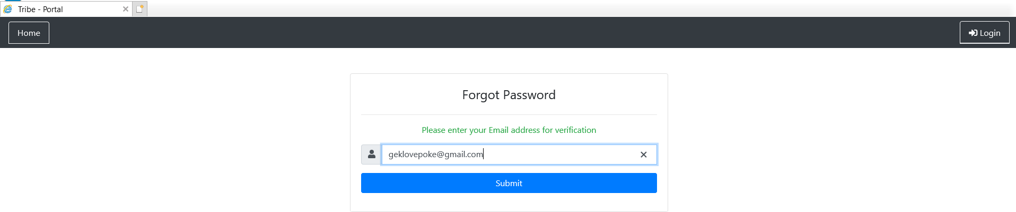

Click “Submit”. A password reset message will be shown.

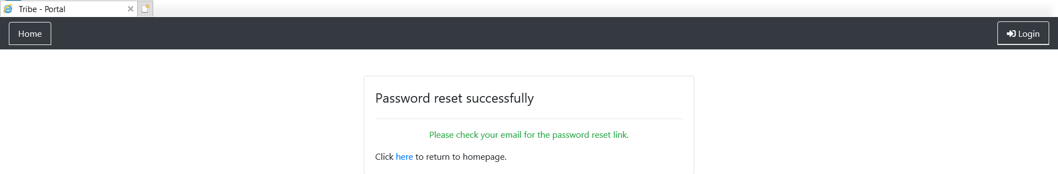

An Email will be sent to the user.

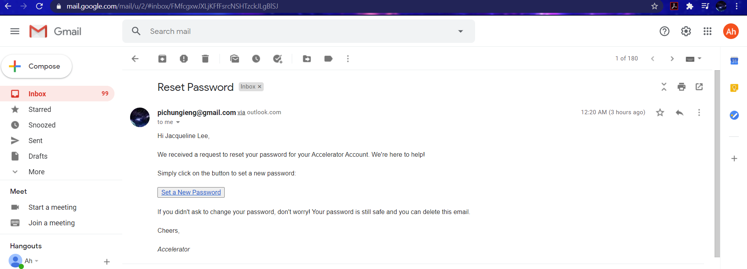

Click “Set a New Password”

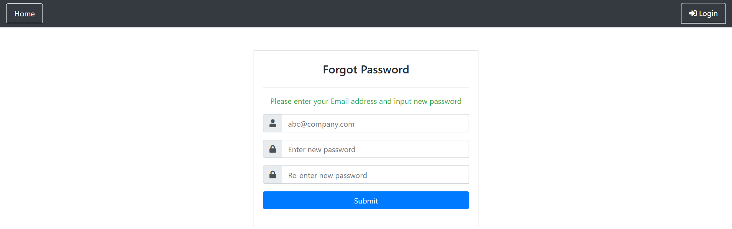

Complete all the necessary fields. Fill in the user’s email, new password and confirmed new password. An example..

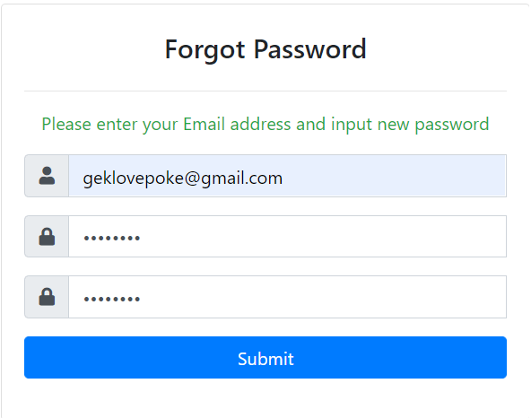

Click “Submit”. If reset successful, a password reset successfully message will be received.

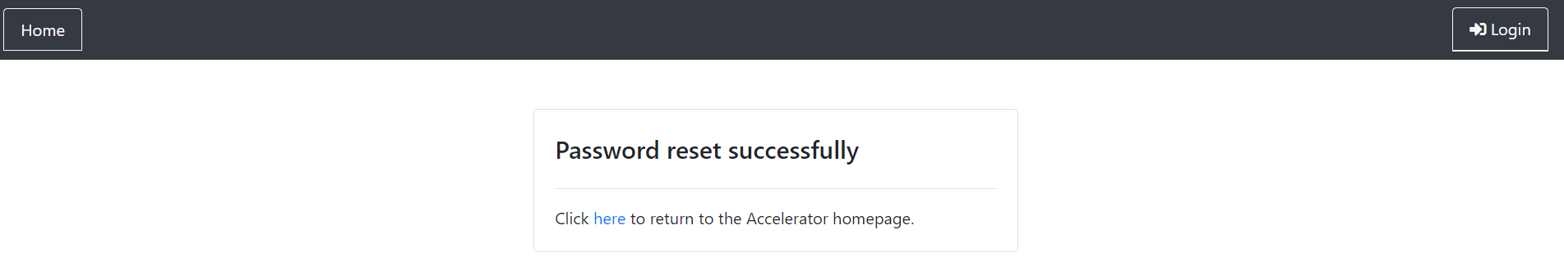

**Calendar Entity**

Creating/Editing an event through the Calendar API (Admin):

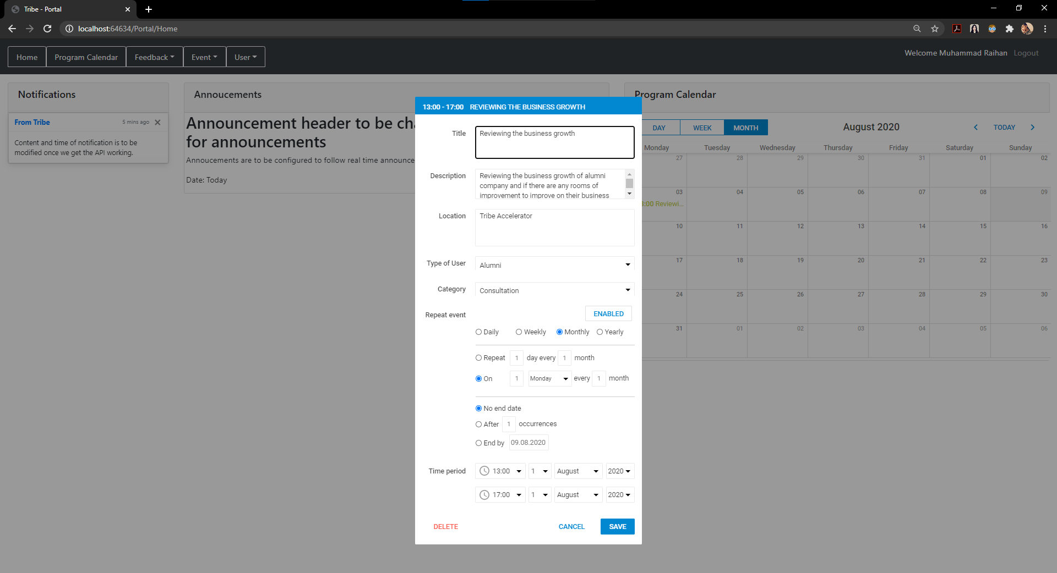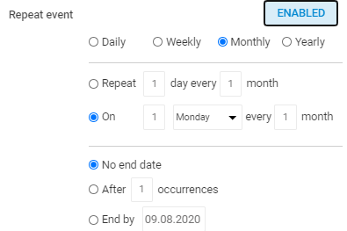

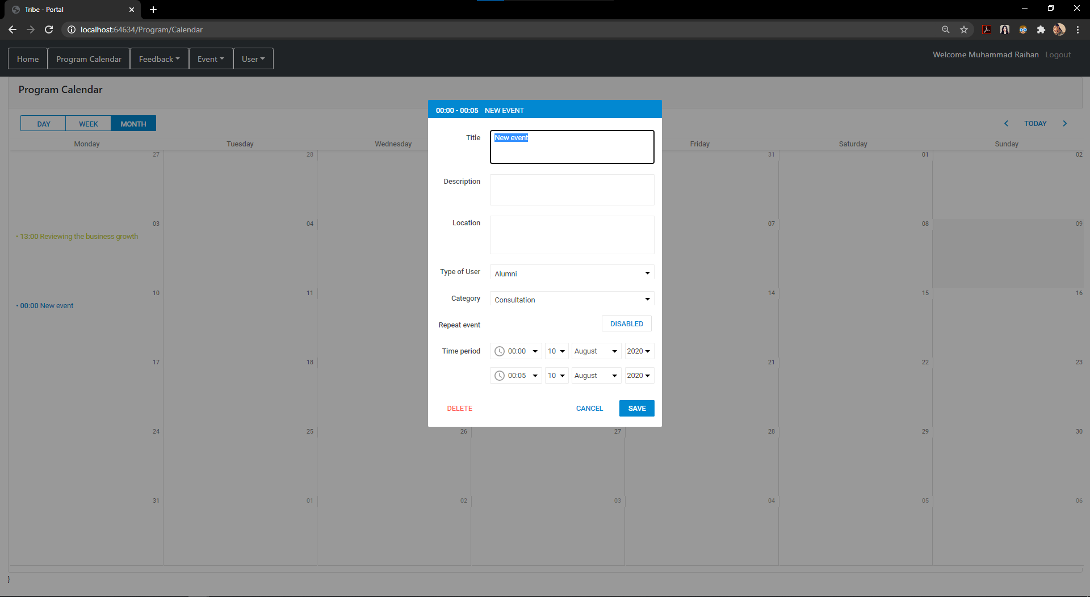

The Calendar API can be found in two pages of the portal. The Homepage of the portal as well as the Program Calendar page. Upon double-clicking a date on the Calendar in the Month view, the admin user will be prompted to enter the fields that are required. If the event is a recurring event, the admin user will have to click the “ENABLED” button to indicate that the event is a repeated event and the admin user will need to indicate what type of recurring event it is and how often it is repeated. Once the details are entered, upon clicking “SAVE”, the event will be saved into the database and on the Calendar and will be reflected on the Calendar in the portal. An email invitation will be automatically triggered and sent to the user group that is specified for the event. For example, if the type of user is “Alumni”, the email will be sent to all the alumni users/participants of the accelerator program.

Editing an event would be the same process except that the fields are returned with previously saved values instead of a blank field. Upon changing the value of a field and clicking “SAVE”, the details of the event will be updated in the database as well as on the Calendar API.

**Deleting an event through the Calendar API (Admin):**

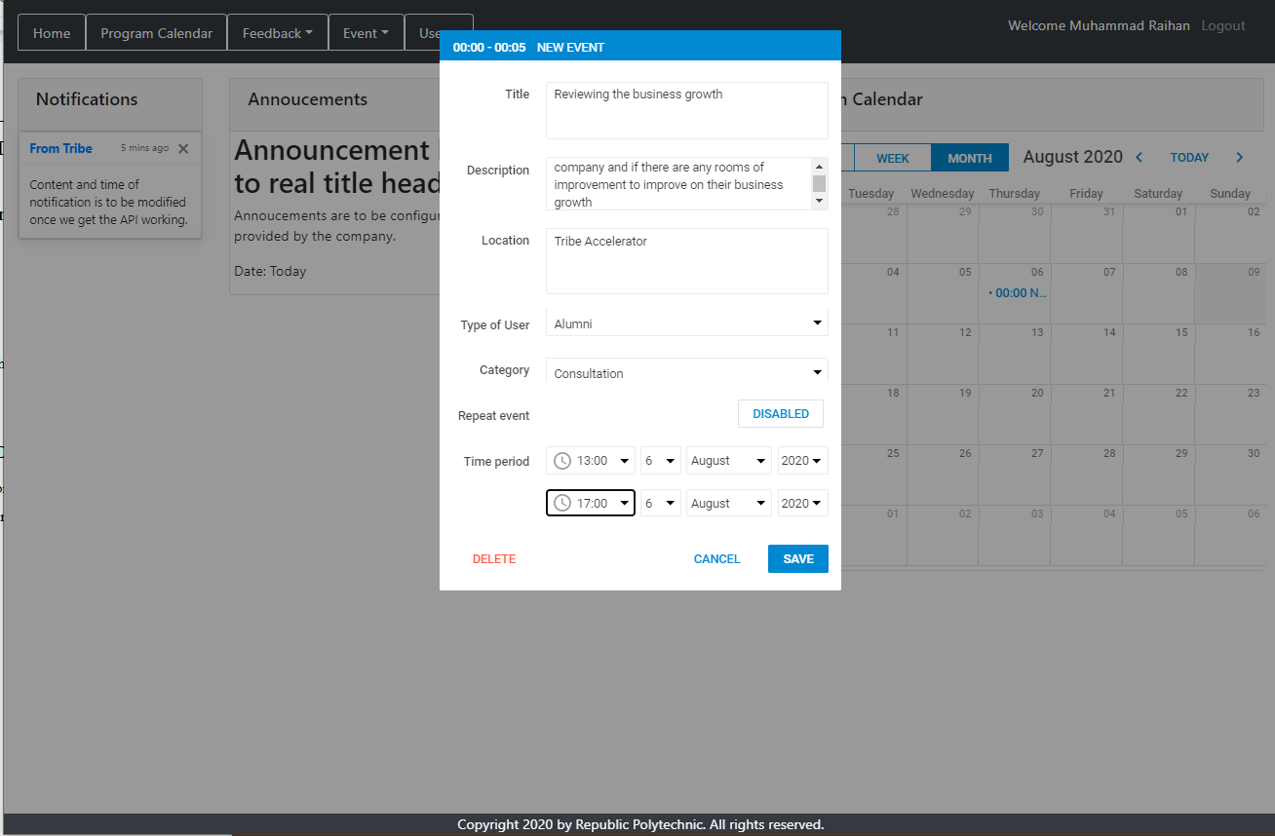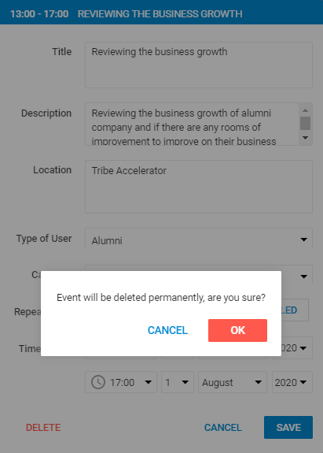

Upon double-clicking a date on the Calendar in the Month view, there is a “DELETE” button where the admin user may trigger in order to delete the event. Upon clicking the button, the user will be prompted for confirmation to delete. If “OK” is clicked and triggered, the event will be permanently deleted from the database and will not be shown on the Calendar in the portal. Else, no changes will be affected and made to the event.

**Viewing the details of the event (Alumni/Startup):**

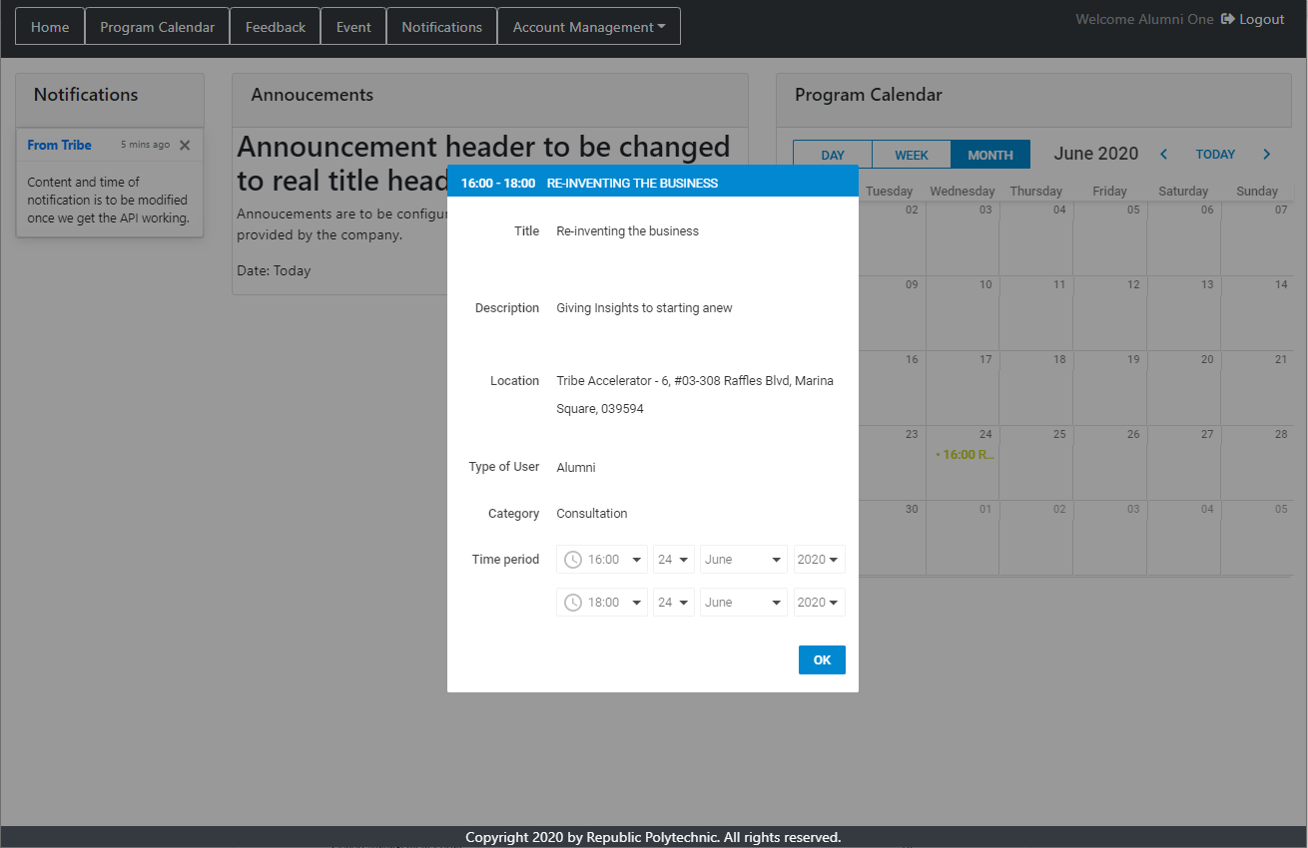

Upon double-clicking an event on the Calendar in any form of its view, the alumni or startup user would be able to view the details of the event without the permission to make any changes to any fields. as shown in the screenshot above, the fields are shown in a read-only format including the dropdown boxes of the time fields which is greyed out to prevent users from making any unexpected changes.

**Event Entity**

From Homepage to Event page:

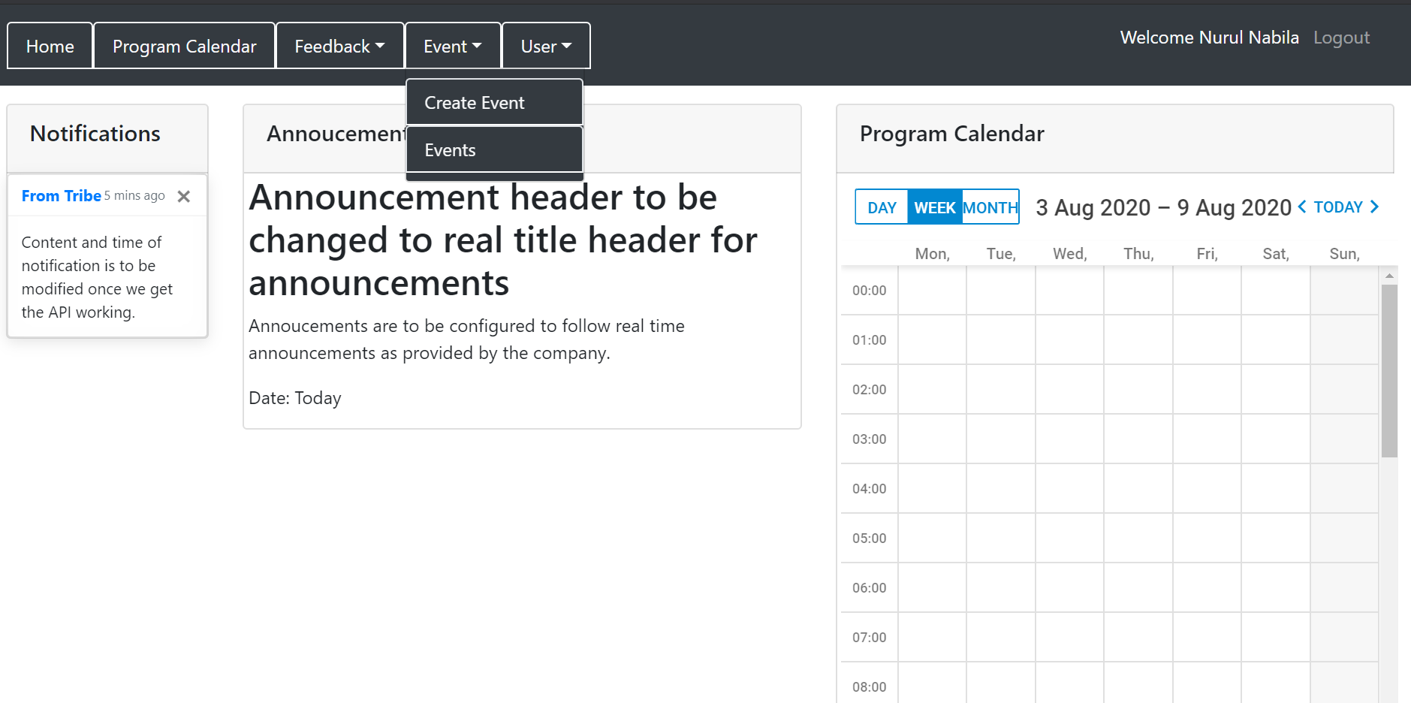

From the Homepage, we can see the word “Event” at the navigation bars found at the top. Click on the “Event” and select either “Create Event” or “Events”

**Creating an Event through Event Entity:**

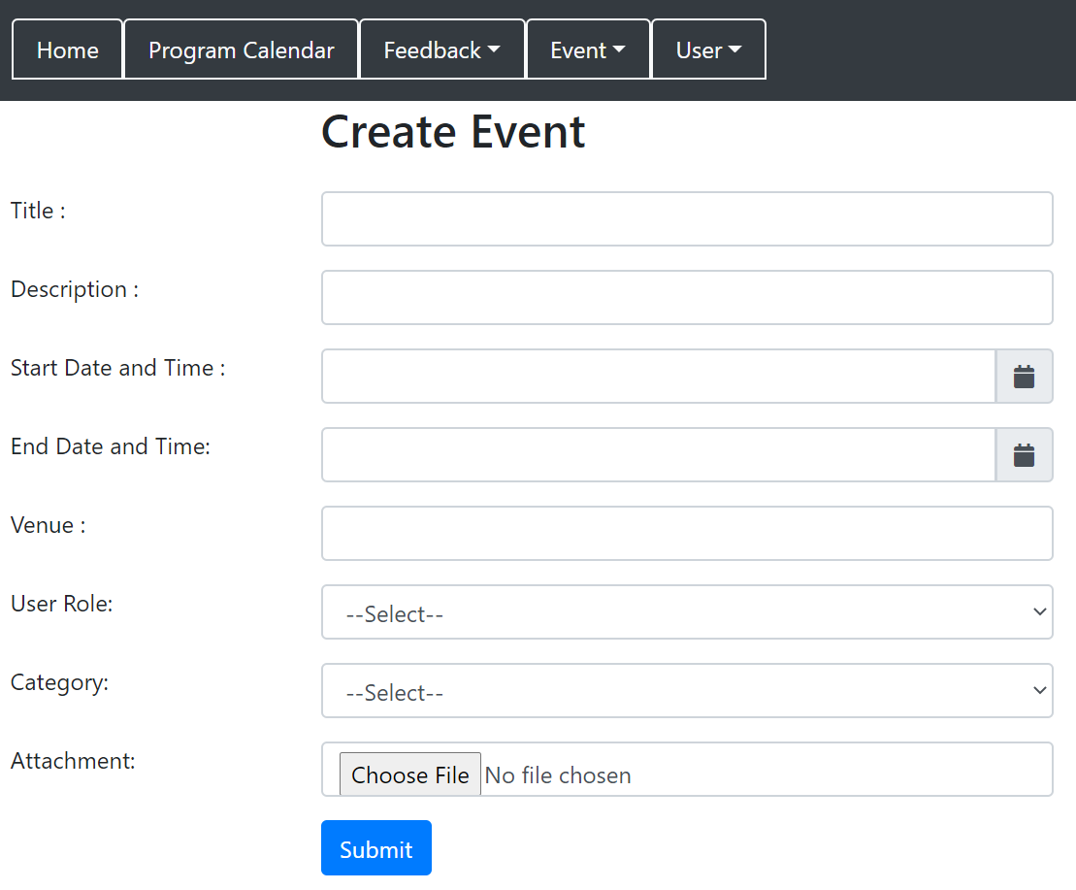

From the Homepage, click “Event” then click “Create Event” in order to create a new event.

Complete all the necessary fields. Fill in the title, description, start datetime and end datetime, venue, user role, category and attachment.

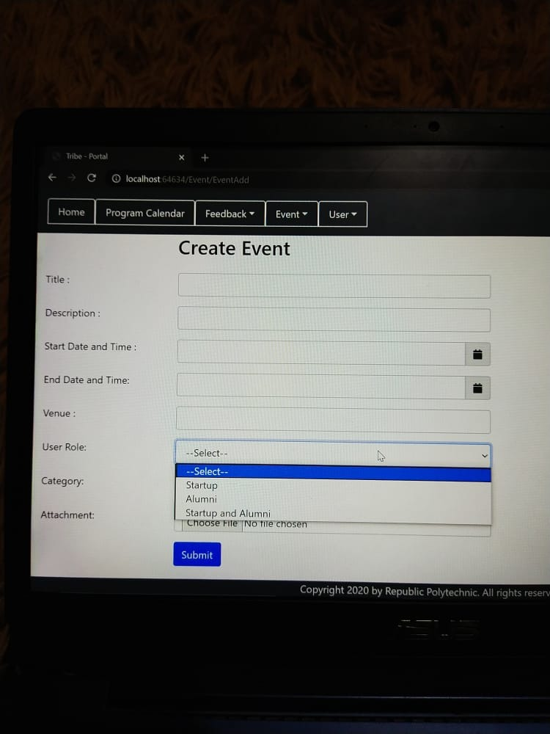

User role is to send this event especially for that particular user role. For the user role, we can select either for alumni, startup or both alumni and startup.

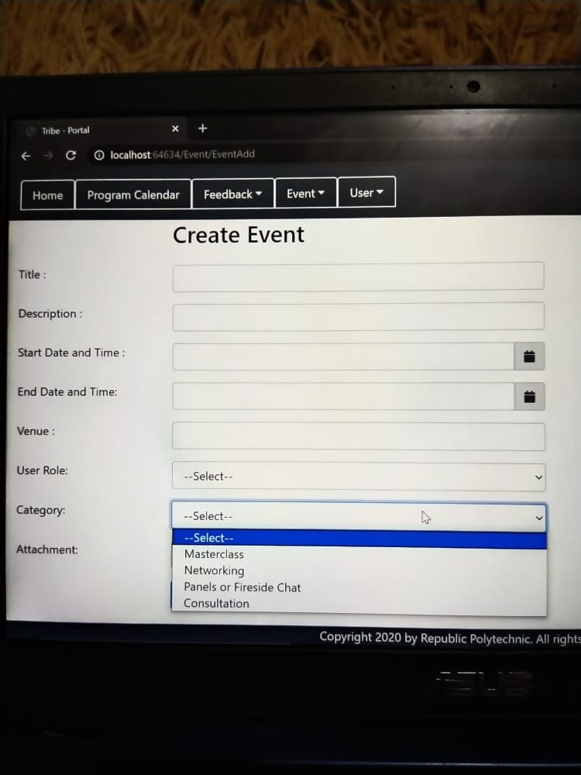

Category can either be Masterclass, Networking, Panels or Friends chat or Consultation. Depending on the events created, the admin can select a specific category for the event.

An Example of a created event:

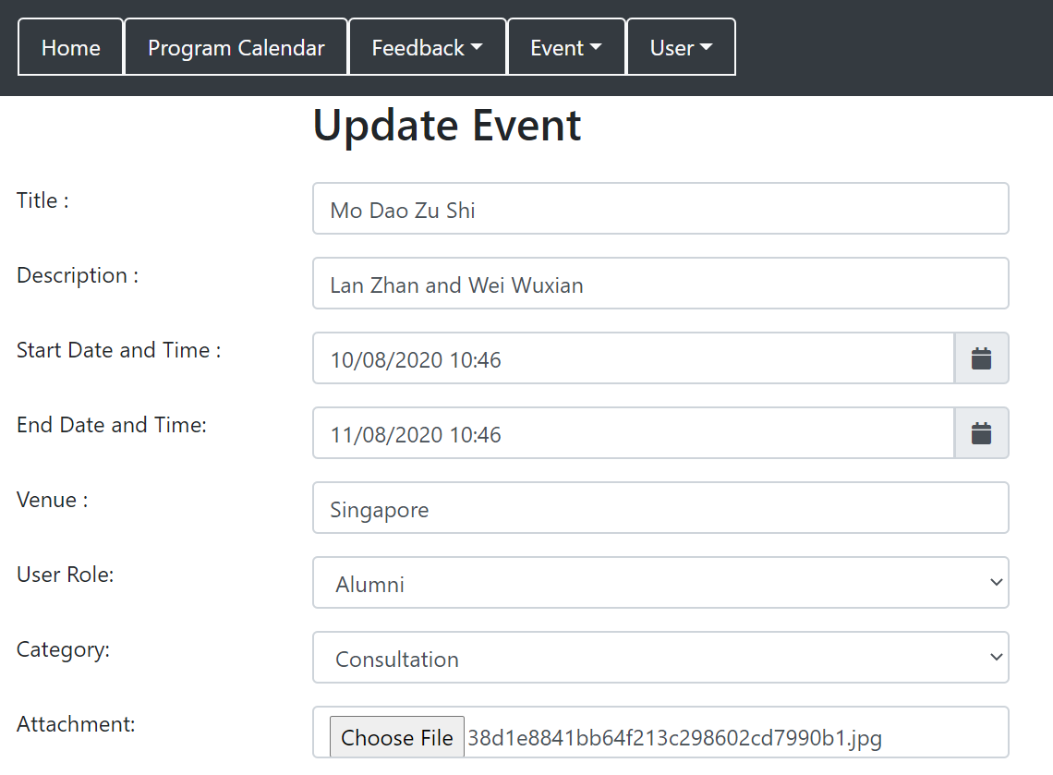

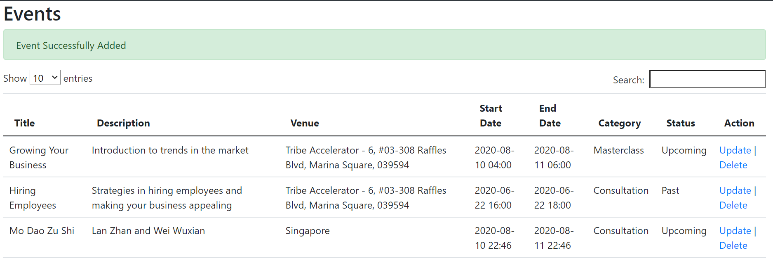

Attachment is for admins to upload files for the startups and alumni to download.

**Update event details:**

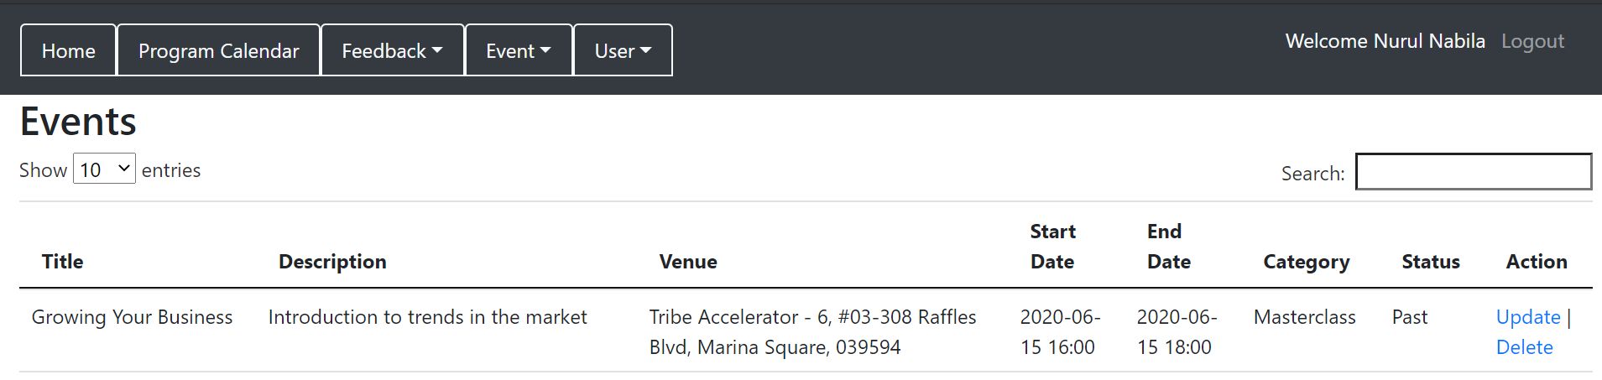

From the Homepage, click “Event” then click “Events” to see the Event list.

From there, click on “Update” located at the “Action” Column.

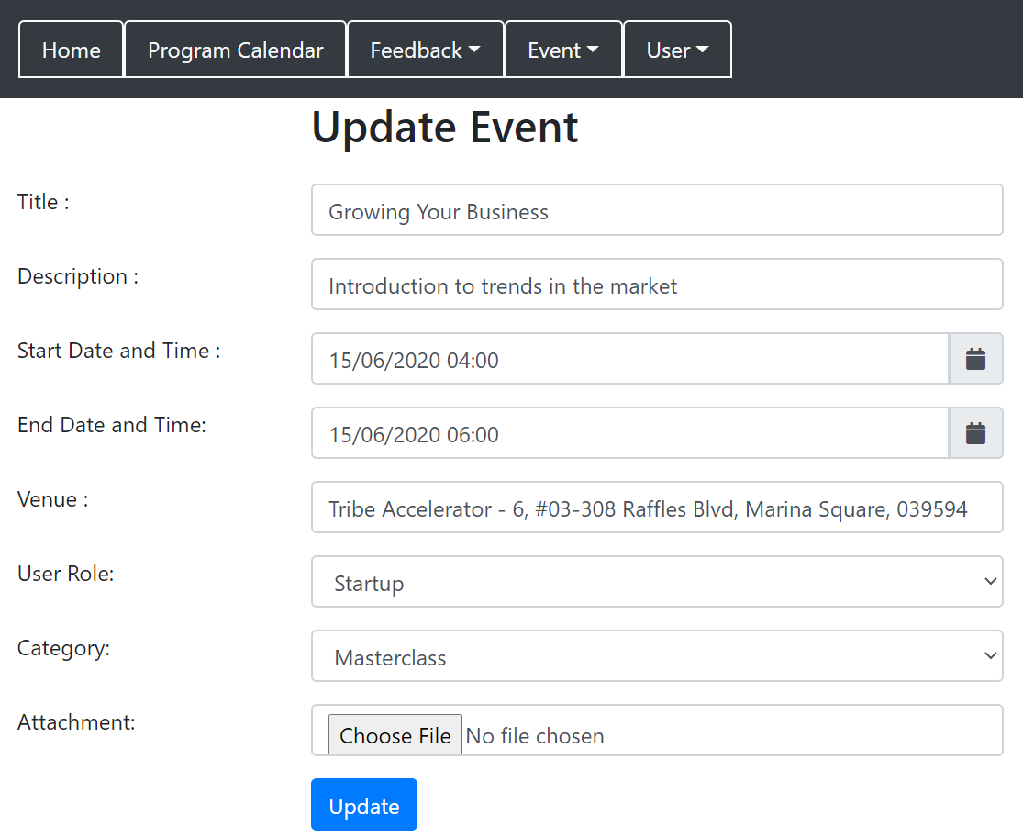

This will be the “Update Event” page of the first event. We can change anything from all the fields. Then after we have change any fields, we will then click “update”.

For example if we were to change the start datetime and end datetime.

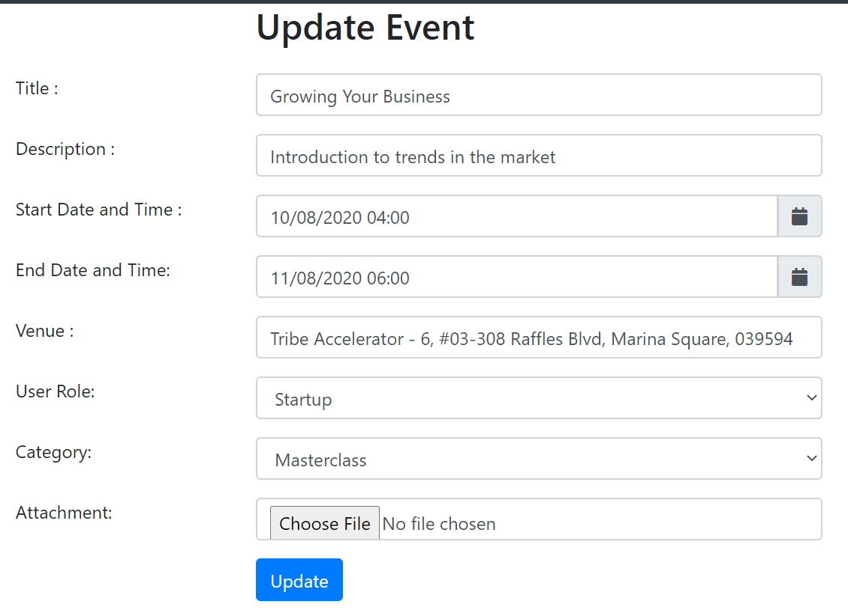

After clicking “Update”, it will then show the Event list page and the new updated details will be shown.

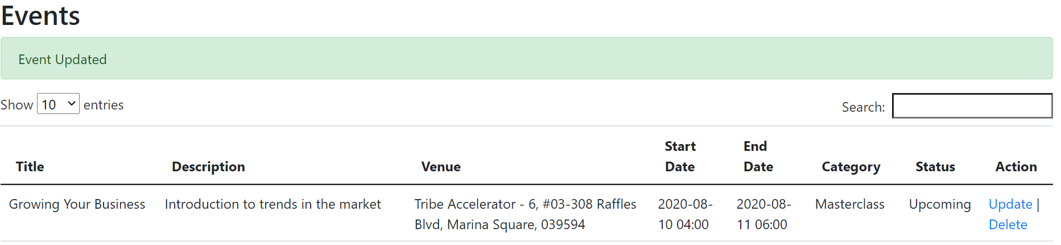

**Deleting an Event**

From the Event List page, we will click “Delete” and there will be a prompt.

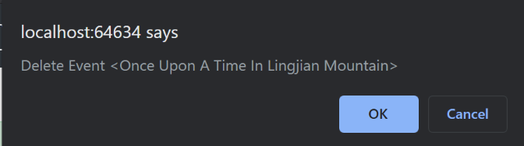

Click “OK”

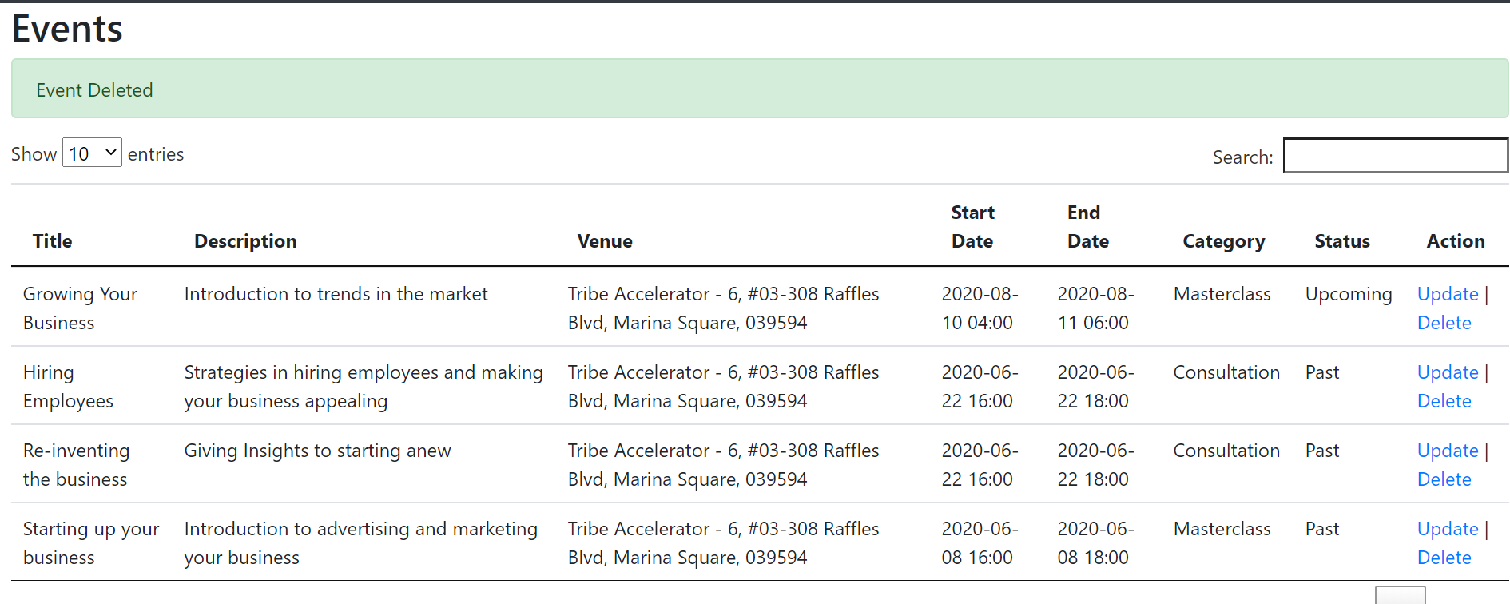

Then the deleted event will not be shown in the event list anymore.

**Individual Event Detail [Startup or Alumni]**

From the Homepage, click “Event” on the navigation bars located on top. It will bring you to the Event list page. from there, we can see the events that are allocated for them. Different user role type has different events created for them. For example, is the Alumni event list page as shown below.

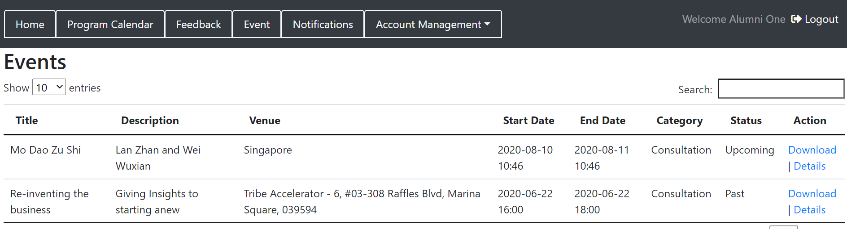

Click at the “Details” located at the “Action” column.

Then, it will show the details of that particular event. Like one of the examples shown below.

